SQL Assignment 1:
Ques 1: Creating sample tables and inserting values.
Create the following tables with given structures and insert sample data as specified:-

A)SALESPEOPLE
SNUM int(4)
SNAME varchar(10)
CITY varchar(10)
COMM float(3,2)

B) CUSTOMER
CNUM int(4)
CNAME varchar(10)
CITY varchar(10)
RATING int(4)
SNUM (4)

C) ORDERS
ONUM int(4)
AMT float(7.2)
ODATE date
CNUM int(4)
SNUM int(4)

Answer:
Commands and Screenshots: Table A SALESPEOPLE
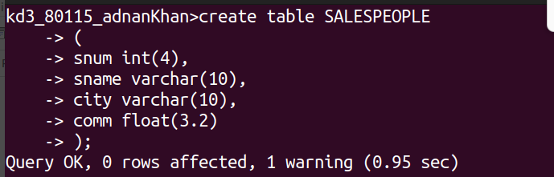

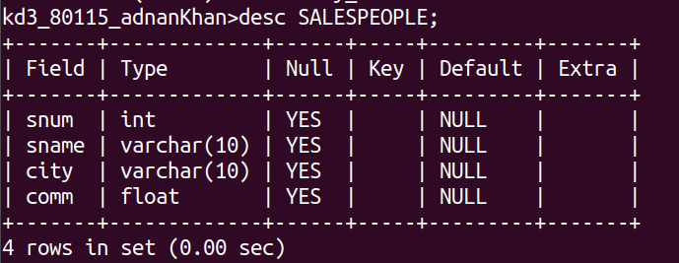

Table B CUSTOMERS
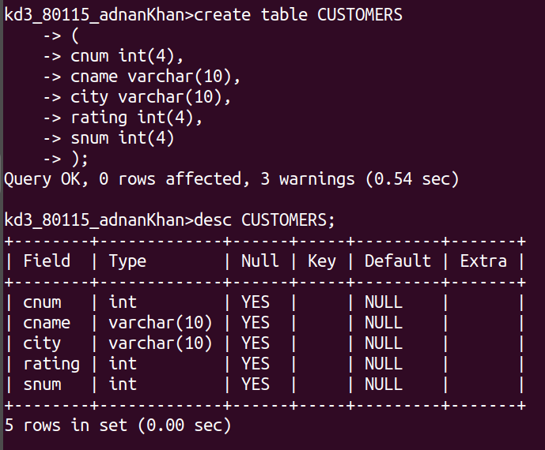

Table C ORDERS

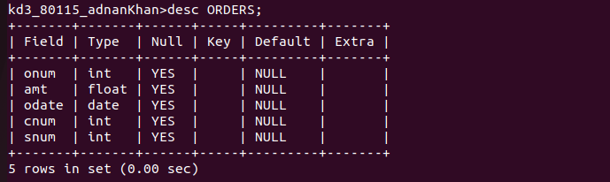

Table SALESPEOPLE
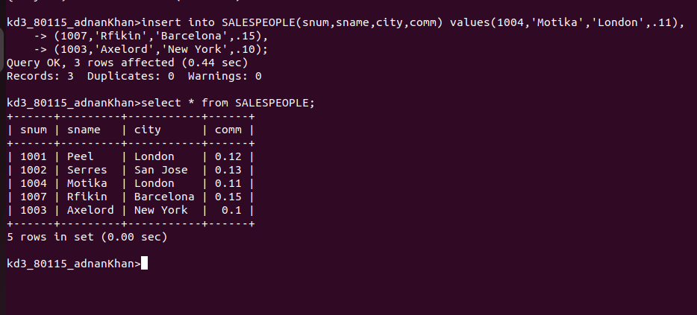

Table CUSTOMERS
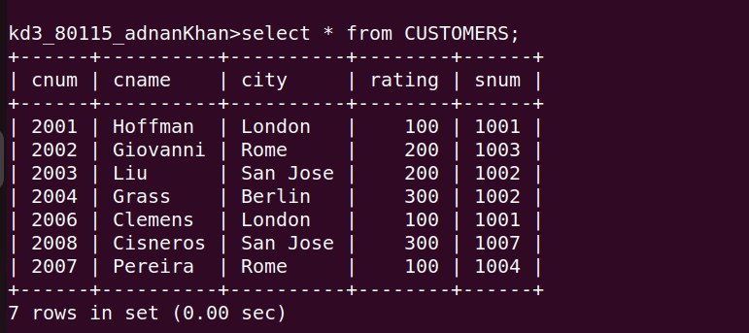

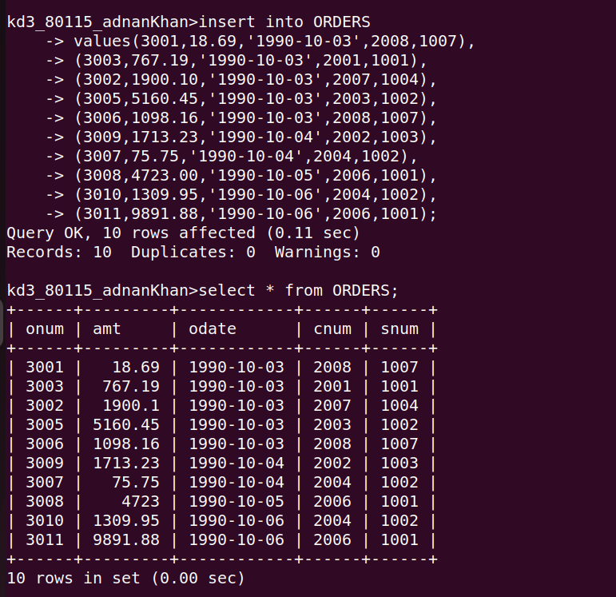
Table ORDERS

